**THE FUTURE OF WORK : DATA ANALYSIS OF GLASS DOOR JOBS**

The project submitted in the internship of the requirements

of the award of the degree

**BACHELOR OF TECHNOLOGY**

**IN**

**COMPUTER SCIENCE ENGINEERING**

Submitted by

TELAPOLU SHILPA 20B41A0501 PEDDINTI BHAVYA SRI 206E1A0527 KANDUKURI PALLAVI 206E1A0514

CHERUKUWADA LAXMI SRI HARSHA 206E1A0508 PERALA DHANUSH 20B41A0504

Under the esteemed guidance of

Mrs. Bharathi Chamarthi

Assistant professor of



**DEPARTMENT OF COMPUTER SCIENCE ENGINEERING**

**GONNA INSTITUTE OF INFORMATION TECHNOLOGY AND SCIENCES**

(Approved by AICTE, New Delhi, affiliated to JNTUGV-Vizianagaram)

Gonnavanipalem, Aganampudi, Parawada (Mandal)

VISAKHAPATNAM-530026

2023

Job analysis is a systematic procedure to analyse the requirements for the job role and job profile. Glassdoor is a website and online platform that provides information about jobs, salaries, and companies. Job analysis is a systematic approach to defining the job role, description, requirements, responsibilities, evaluation, etc. It helps in finding out the required level of education, skills, knowledge, training, etc for the job position. It also depicts the job worth i.e. measurable effectiveness of the job and contribution of job to the organisation Thus, it effectively contributes to setting up the compensation package for the job position.

Lack of analysis of Glassdoor jobs can result in limited understanding of job market trends, difficulty in finding relevant job opportunities, inability to attract and retain top talent, and lack of insight into company branding and reputation.

The purpose of this project is to conduct an analysis of Glassdoor job postings to gain insights into current and emerging job market trends, identify in-demand skills and experience, and understand how employers can improve their employer branding and reputation to attract and retain top talent.

Technical Architecture:

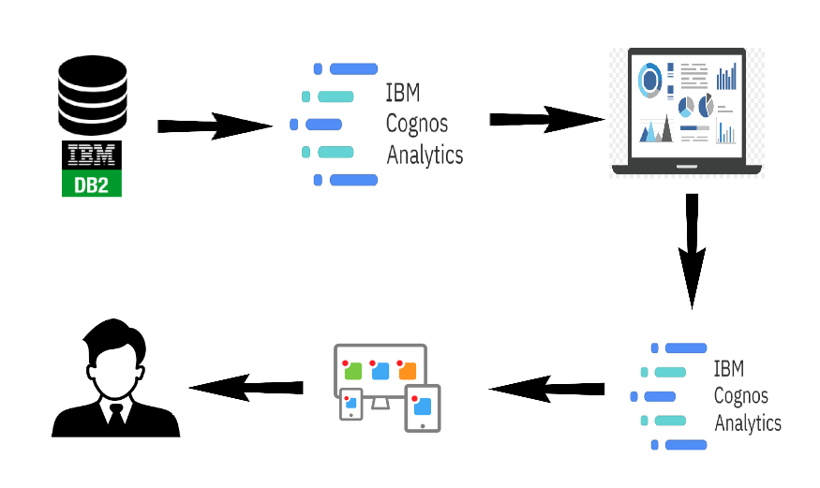

### **Define Problem / Problem Understanding**

The business problem for the Glassdoor job data analysis project is to gain insights into the job market and employment trends to help various stakeholders make informed decisions. Some potential business questions that can be addressed through the analysis are:

1. Job Market Overview: What is the current state of the job market in terms of the number of job openings, locations with the most opportunities, and popular job titles?

2. Salary Analysis: What is the salary distribution for different job roles? Are there any significant differences in salaries based on location, experience, or industry?

3. Company Competitiveness: Which companies are hiring the most and offering the most competitive salaries?

4. Job Location Preferences: Where are most of the job opportunities concentrated, and how do location preferences vary across industries?

5. Job Category Insights: What are the most sought-after job categories, and how have they evolved over time?

6. Industry Analysis: Which industries have the highest demand for talent, and what are the typical job roles within those industries?

7. Skill Requirements: What are the most in-demand skills and qualifications for various job roles?

8. Employee Satisfaction: Is there a correlation between employee satisfaction ratings and the companies they work for or their job roles?

9. Diversity and Inclusion: How diverse and inclusive is the job market in terms of gender and ethnicity representation?

### **Specify The Business Problem**

### The problem understanding of a Glassdoor-like job platform involves recognizing the challenges and pain points that job seekers and employers face within the job search and hiring process. Here are some key problems that a Glassdoor jobs platform aims

1. Limited Company Insights: Job seekers often struggle to find accurate and detailed information about companies they are interested in. They lack insights into company culture, employee experiences, work-life balance, and growth opportunities. This lack of information makes it difficult for them to assess whether a company is a good fit for their career goals and values.

2. Unclear Compensation Information: Job seekers often have little to no information about salary ranges for specific roles within different companies and industries. This lack of transparency can lead to uncertainty during salary negotiations and make it difficult for job seekers to assess whether an offer is competitive.

3. Inefficient Hiring Process: Employers face challenges in attracting the right candidates for their job openings. The lack of a standardised platform for sharing detailed information about their company and job listings can result in an influx of unqualified applicants and a longer hiring process.

4. Unreliable Reviews: Both job seekers and employers struggle with the reliability of online reviews. Job seekers may encounter exaggerated or misleading reviews that do not accurately represent a company's reality. Employers may also face unfair or inaccurate reviews that impact their reputation.

5. Difficulty in Employer Branding: Employers need a platform to showcase their company's values, work culture, and benefits to attract top talent. The absence of a reliable platform can lead to difficulties in establishing a positive employer brand.

6. Lack of Diversity and Inclusion Insights: Job seekers and employers alike face challenges in identifying diverse and inclusive workplaces. Without access to information about a company's commitment to diversity and inclusion, it's harder for both parties to make informed decisions.

7. Missed Opportunities: Job seekers may miss out on potential job opportunities that align with their preferences and values simply because they lack the necessary insights to make informed decisions.

8. Impact on Recruitment Strategies: Employers need accurate information about industry trends, employee expectations, and competitor offerings to refine their recruitment strategies and remain competitive in attracting top talent.

Glassdoor's business model addresses these problems by offering a platform where employees and former employees can anonymously review companies, share insights, and provide details about their experiences. This platform empowers job seekers with valuable information to make informed decisions, while also allowing employers to showcase their company's strengths and address any areas of improvement. Through this transparency, Glassdoor aims to create a more efficient and effective job market for both job seekers and employers.

### **Business Requirements**

Understanding the data of different jobs provided by glassdoor can help businesses and personnel to analyse current market trends in hiring, packages offered, etc. Businesses need to understand the glassdoor jobs data in order to get valuable insights. Job analysis is a crucial step in validating all major personnel activities. Employers must be able to show that their screening tools and appraisals are actually related to performance on the job in question. Doing this, of course, requires knowing what the job entails, which in turn requires a competent job analysis. The ultimate goal is to gain insights and improve performance through data visualisation techniques.

The business requirements of a Glassdoor-like job platform outline the key functionalities and features that the platform must have to meet the needs of job seekers, employers, and other stakeholders. These requirements guide the development process and ensure that the platform effectively addresses the challenges in the job market. Here are some essential business requirements:

1. User Registration and Profiles:

Allow job seekers and employers to create accounts and build profiles.

Collect relevant information such as contact details, work experience, education, skills, and preferences.

2. Job Search and Listings:

Provide a user-friendly search interface with advanced filtering options (location, industry, job type, experience level, etc.).

Display accurate and up-to-date job listings from various industries and companies.

3. Company Insights:

Allow employers to create company profiles with information about their mission, values, culture, benefits, and diversity initiatives.

Enable employees and former employees to write reviews about their experiences, work environment, management, and more.

4. Salary Information:

Provide salary insights for different job roles, industries, and locations.

Allow users to anonymously share their salary information to contribute to the salary database.

5. Interview Experiences:

Allow users to share their interview experiences, including the interview process, questions asked, and overall impressions.

6. User Interaction and Engagement:

Enable users to rate companies, job listings, and reviews to contribute to the platform's credibility.

Allow users to comment on reviews and engage in discussions.

7. Application Process:

Allow job seekers to apply for jobs directly through the platform.

Provide tools for employers to manage applications, shortlist candidates, and communicate with applicants.

8. Privacy and Security:

Ensure data privacy by implementing secure user authentication and data encryption.

Allow users to control the visibility of their profiles and contributions.

9. Mobile Responsiveness:

Design the platform to be responsive and accessible on various devices, including smartphones and tablets.

10. Search Engine Optimization (SEO):

Implement SEO strategies to ensure the platform's visibility in search engines and improve organic traffic.

11. User Feedback and Reporting:

Provide a way for users to report inappropriate content, reviews, or profiles.

Allow users to provide feedback on the platform's usability and features.

12. Analytics and Insights:

Implement analytics tools to track user engagement, job listing performance, and other relevant metrics.

Provide insights to employers about the effectiveness of their company profiles and job listings.

13. Social Media Integration:

Allow users to share job listings, reviews, and other content on social media platforms.

Provide integration with social media accounts for easier profile creation and login.

14. Notification System:

Send users notifications about relevant job listings, updates, and interactions on the platform.

15. User Support and Help Center:

Provide a help centre with FAQs, guides, and contact information for user support.

These business requirements form the foundation of a Glassdoor-like job platform, aiming to enhance transparency, communication, and efficiency in the job market for both job seekers and employers.

### **Literature Survey**

A literacy survey for Data Analysis of Glassdoor Jobs involves reviewing multiple job roles in a particular domain offered by a particular organisation belonging to a given industry and sector. Job analysis defines the organisation of jobs within a job family. It allows units to identify paths of job progression for employees interested in improving their opportunities for career advancement and increasing compensation.

1. Transparency in Job Market:

Research might discuss the significance of transparency in the job market and how platforms like Glassdoor contribute to providing insights into company culture, salaries, benefits, and employee experiences.

2. Impact on Job Seekers:

Studies might delve into how job seekers use Glassdoor to make informed decisions about job applications, compare companies, negotiate salaries, and gauge workplace environments.

3. Employer Branding and Reputation:

Literature could explore how Glassdoor and similar platforms influence employer branding and how organisations manage their online reputation through reviews and responses.

4. Job Market Efficiency:

Researchers might assess how these platforms impact the efficiency of the job market by matching job seekers with better-fitting positions and helping companies attract candidates who align with their culture.

5. Review Authenticity and Bias:

Literature could discuss the authenticity of reviews on platforms like Glassdoor and examine potential sources of bias in reviews, such as disgruntled employees or competitors.

6. Employee Well-being and Retention:

Studies might investigate whether platforms like Glassdoor impact employee satisfaction, well-being, and retention rates, considering how employee feedback could drive positive changes within companies.

7. Salary Transparency and Equity:

Researchers could explore how providing salary information affects salary negotiation dynamics, pay equity, and the narrowing of gender and racial pay gaps.

8. Legal and Ethical Considerations:

Literature might touch on legal and ethical concerns related to anonymous reviews, employee privacy, and potential consequences for companies.

9. Impact on Recruitment Strategies:

Studies might examine how companies adapt their recruitment strategies based on the insights gained from platforms like Glassdoor.

10. Online Reputation Management:

Researchers could investigate how companies respond to reviews, both positive and negative, and the effects of these responses on job seekers' perceptions.

11. Credibility and Trustworthiness:

Literature might discuss how Glassdoor maintains credibility and user trust through verification processes, content moderation, and quality control.

### **Social Or Business Impact**

Social Impact: This project can help job seekers make more informed decisions about their careers and negotiate for better compensation and working conditions. This can ultimately contribute to greater economic mobility and reduce income inequality.

Business Model/Impact: It can help to improve retention rates, reduce turnover costs, and increase productivity. An analysis of Glassdoor jobs can provide insights into what employees value most, helping employers to create a better work environment that attracts and retains top talent.

Social Impact:

1. Transparency and Empowerment: Glassdoor has empowered job seekers with insights into company cultures, salaries, benefits, and employee experiences. This transparency helps individuals make more informed decisions about their career choices.

2. Salary Equity:The platform has contributed to discussions about pay equity by providing users with information about salary ranges for different roles, helping to address gender and racial pay gaps.

3. Workplace Accountability: Companies are held more accountable for their practices and treatment of employees. Poorly-reviewed companies face reputational risks, which can incentivize improvements in work environments.

4. Employee Voice: Glassdoor provides a platform for employees to voice their opinions anonymously, potentially leading to positive changes within companies based on employee feedback.

5. Job Market Dynamics: The platform has altered the dynamics of the job market by making it easier for job seekers to find positions that align with their values and preferences.

6. Encouraging Positive Employer Practices: Companies with positive reviews are incentivized to maintain and enhance their work culture to attract and retain top talent.

7. Diversity and Inclusion: The platform can shed light on companies' efforts towards diversity and inclusion, enabling job seekers to assess whether an organisation values these principles.

Business Impact:

1. Employer Branding:Glassdoor has become a vital aspect of employer branding. Companies with positive reviews attract better-suited candidates, contributing to the creation of a strong employer brand.

2. Recruitment Strategies: Employers can use insights from Glassdoor to adjust their recruitment strategies, tailoring them to align with job seekers' preferences and addressing areas of concern.

3. Feedback Loop: Employers can gain valuable insights from reviews, helping them identify strengths and weaknesses, enhance employee experiences, and refine their HR strategies.

4. Talent Attraction and Retention:Positive reviews on Glassdoor can lead to increased interest from potential employees and contribute to higher retention rates.

5. Market Competitiveness: Companies can analyse competitor reviews to benchmark themselves and gain insights into what competitors are doing well or poorly.

6. Improving Workplace Culture:Companies may take action to improve their culture, address employee concerns, and enhance their overall working environment to receive better reviews.

7. Adapting Compensation Strategies: Glassdoor's salary insights help companies adjust their compensation packages to remain competitive in attracting and retaining talent.

8. Crisis Management:Companies can address negative reviews promptly and professionally to mitigate potential damage to their reputation.

9. Investor and Stakeholder Perception: Glassdoor ratings and reviews can influence the perception of potential investors, partners, and stakeholders.

### **Data Collection & Extraction From Database**

Data collection is the process of gathering and measuring information on variables of interest, in an established systematic fashion that enables one to answer stat research questions, test hypotheses, and evaluate outcomes and generate insights from the data.

The process of data collection and extraction from a database similar to Glassdoor jobs involves a series of steps to retrieve the desired information efficiently and accurately. Here's a general outline of how this process could work:

1. Data Source Identification:

Identify the specific data you want to extract from the Glassdoor-like database. This could include job listings, company reviews, salaries, interview experiences, etc.

2. Data Access and Permissions:

Ensure you have proper authorization and access to the database, respecting any terms of use or privacy policies.

3. API Access (if available):

Check if the platform provides an Application Programming Interface (API) that allows you to access data programmatically. APIs can provide structured and controlled access to the data.

4. Web Scraping (if applicable):

If an API is not available, web scraping might be an option. This involves programmatically navigating the website and extracting data from the HTML source code.

5. Data Extraction Techniques:

Depending on the data format, you may need to use techniques such as regular expressions, HTML parsing libraries (like Beautiful Soup), or JSON/XML parsers.

6. Database Queries (if applicable):

If you have direct access to the database, you can write SQL queries to extract the required data.

7. Data Transformation:

Extracted data may need to be transformed into a structured format like JSON, CSV, or a database table.

8.Handling Pagination:

Websites often paginate results (showing a limited number per page). You need to handle pagination to get all the data you need.

9. Rate Limiting and Throttling:

If using an API, make sure you adhere to rate limits and any guidelines to avoid overloading the server.

10.Data Storage:

Store the extracted data in a secure and organised manner. You might use databases, spreadsheets, or other storage solutions.

11.Data Integrity and Quality:

Clean and validate the extracted data to ensure accuracy. Handle missing or inconsistent data appropriately.

### **Storing Data In DB2 & Connect DB2 With Cognos**

In this video after the dashboard the next step is to create a database so for that go to this catalogue option type DB2 you have a good connection connectivity select location have to select after that please correct this light which is free and accept the terms and c basically we are going to Hyderabad from the local system in our database so just click on this please write the name literacyondition simply concrete since I already credit database section the database you have your DP to install so just selected an inside that existing education your service connection I will get added so you can explorate now after this is go to this manage section in this manage go to the UI y I am going to loader table so click on this select assetsou can go to you bhai so just click on this about data have you going to load our data set you can go to you I Tamil right selected DB2 okay click on next ktpc viral go back to your service details of the iron cloud account you will find jdpc URL and password test connection get it success you get a successful message you not allowed create connected with the I okay go back to this click on manage literacy news okay inside this table go back to the manage data server connection and Saturday open data server select literacy electro scheme going to load the table in the so this how your going to establish connection with IBM Congress and between having content new this was the table that they added

**Connect DB2 With Cognos**

In this video we are going to see like how to integrate IBM DP to with IBM commerce so for that very fast thing we have to login with the admin cloud account you can see the dashboard so for that go to this catalogue option please type DP to should you have a good connection connectivity DP to the very first option you will get like DB to us South Region okay after that please correct this light not which is free and accept the terms and condition simply concrete since I already credit 1302 is go to the click on this hamburger menu that is nothing but three lines with three database section have you due to install so just se DP to inside that any two existing education your service connection I will get added so you can explore it is go to this manage section in this manage go to the UI please wait for the ways to get loaded file selection you have to please go to the folder video data set is there in my place it's very much already so I am going to create a new table for my click on create collector dv2 click on next go back to your service detail of the iron cloud account and inside this education you will find the jdbc URL copy down within the court content and come back to the data can see the table has been loaded click on done is how your going to establish a condition with I didn't Knox and between having clouded

**Data Preparation**

Data modules are containers that describe data and rules for combining and shaping data to prepare it for analysis and visualisation in IBM Cognos Analytics. Data module sources. Data modules can be based on data servers, packages, uploaded files, data sets, and other data modules

1. Data Collection:

Web Scraping: You can use web scraping techniques to extract job-related data from Glassdoor. Python libraries like Beautiful Soup or Scrapy can help with this process. Make sure to review Glassdoor's terms of use and scraping policies before proceeding.

2. Data Cleaning:

Remove Duplicates: Sometimes, job listings might appear multiple times due to minor variations. Remove duplicate listings to ensure the accuracy of your analysis.

Handle Missing Values:Clean up missing or incomplete data. For example, if a salary field is missing, you might need to decide whether to exclude that record or impute the missing value.

Standardise Data: Normalise or standardise fields like job titles, locations, and company names to ensure consistency.

3. Data Transformation:

Text Data Processing:Process textual data such as job descriptions and reviews. This could involve techniques like tokenization, stop word removal, stemming, and sentiment analysis.

Feature Engineering: Create new features that could be useful for analysis. For example, you could calculate the average company rating based on reviews or categorise job titles into different job categories.

4. Data Integration:

External Data:You might want to integrate Glassdoor data with other external datasets for more comprehensive analysis. For instance, you could merge Glassdoor company data with financial data from another source.

5. Data Storage:

Database:Store your cleaned and transformed data in a database for easy access and manipulation. You could use a relational database like MySQL or PostgreSQL.

CSV/Excel: If your dataset is not too large, you can save it as a CSV file or an Excel spreadsheet.

6. Data Analysis and Visualization:

Statistical Analysis: Analyse the data to gain insights. Calculate averages, medians, and other relevant statistics for job salaries, ratings, and other attributes.

Visualisation: Create graphs and charts to visually represent your findings. Tools like Python's Matplotlib, Seaborn, or libraries in R can help

### **Prepare The Data For Visualization**

How to integrate IBM DP to with IBM commerce so for that very fast thing we have to login with the admin cloud account you can see the dashboard so for that go to this catalogue option please type DP to should you have a good connection connectivity DP to the very first option you will get like DB to us South Region okay after that please correct this light not which is free and accept the terms and condition simply concrete since I already credit 1302 is go to the click on this hamburger menu that is nothing but three lines with three database section have you due to install so just se DP to inside that any two existing education your service connection I will get added so you can explore it is go to this manage section in this manage go to the UI please wait for the ways to get loaded file selection you have to please go to the folder video data set is there in my place it's very much already so I am going to create a new table for my click on create collector dv2 click on next go back to your service detail of the iron cloud account and inside this education you will find the jdbc URL copy down within the court content and come back to the data can see the table has been loaded click on done is how your going to establish a condition with I didn't Knox and between having clouded

We need to check whether the data is uploaded or not to content you need to go to this main menu click on new to select the data that you have just uploaded so we only have multiple table you can I can view the table I can create a shortcut of table alias name of the table and copy of table I can but I cannot do these operation now when we come to our data our data is clean data set job title that is showing the title of your job role title of the Google proposed by the company then estimated salary then job then rating of company name size of the company then type of ownership what type of owner sector what sector revenue Cancel I would recommend you what you need to do then you need to and refresh it so that changes will be reflected for that we first need to save it so click on save Moti and now where content I will create a new folder project title now you can multiple task if you want to change if you want to change the title column name you can use rename if you want to cut anything copy anything you can do if you want to format the data you can format the data particular format nothing showing date and time right you can remove the particular colum if you don't wanted if you want to hide it from the use you can hide it from the use of if you want to clean it you can clean it if you want to split it utens split it okay so I go to That has been analyzed I want to replace one with others I go to clean replace this value which value minus one with null and then can see one year so what you need to do just click on Save Water controller it is not safe is not there that means all the things that will save ok now refresh the page So this is let us take dollar similarly you can do for max salary also let us know information currency and US dollars similarly for every salary also currency US dollar steps in data preprocessing these are some of the steps that we can purpose of this data report.

### **Data Visualization**

Data visualisation is the process of creating graphical representations of data in order to help people understand and explore the information. The goal of data visualisation is to make complex data sets more accessible, intuitive, and easier to interpret. By using visual elements such as charts, graphs, and maps, data visualisations can help people quickly identify patterns, trends, and outliers in the data.

1. Frosted Glass with Graphics:

Use frosted or etched glass with applied graphics to display data. This maintains privacy while allowing light to pass through. You can have data-driven graphics, charts, or even abstract representations that convey the information you want.

2. Vinyl Decals:

Apply vinyl decals directly onto the glass. These decals can include charts, graphs, icons, or any other visual representations of data. They are relatively easy to apply and remove, making them a flexible option.

3. Interactive Displays:

Depending on your budget and technological capabilities, you could incorporate interactive displays on the glass doors. These could be touch screens that allow users to interact with data in real-time.

4. LED Panels:

LED panels can be embedded into glass doors to create dynamic displays. You can program these panels to show different visualisations that change over time. This can be especially eye-catching in a well-lit environment.

5. Projection Mapping:

Using projection mapping technology, you can project data visualisations onto glass doors. This allows for a versatile display that can change as needed.

6. Smart Glass:

Smart glass technology allows you to change the transparency of the glass. You could use this to reveal or hide data visualisations as needed.

7. Colour-Coded Graphics:

Use coloured films or paints to create colour-coded data representations directly on the glass. This can be a more artistic approach to displaying data.

8. QR Codes:

Place QR codes on the glass that, when scanned, lead users to online data visualisations or information related to the displayed data.

9. Data Art:

Collaborate with artists who specialise in turning data into art. They can create unique and visually appealing representations of your data.

10. Data-Driven Stained Glass:

Create stained glass designs that incorporate data-driven patterns or themes. This can result in a beautiful and symbolic display.

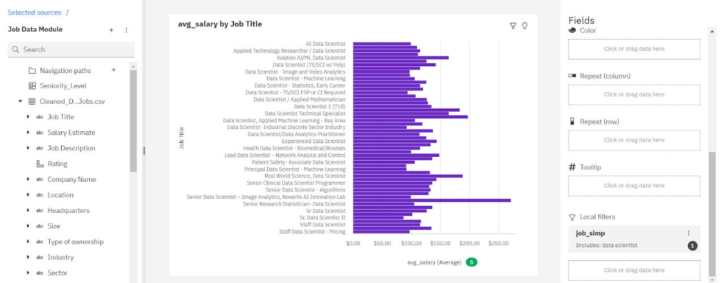

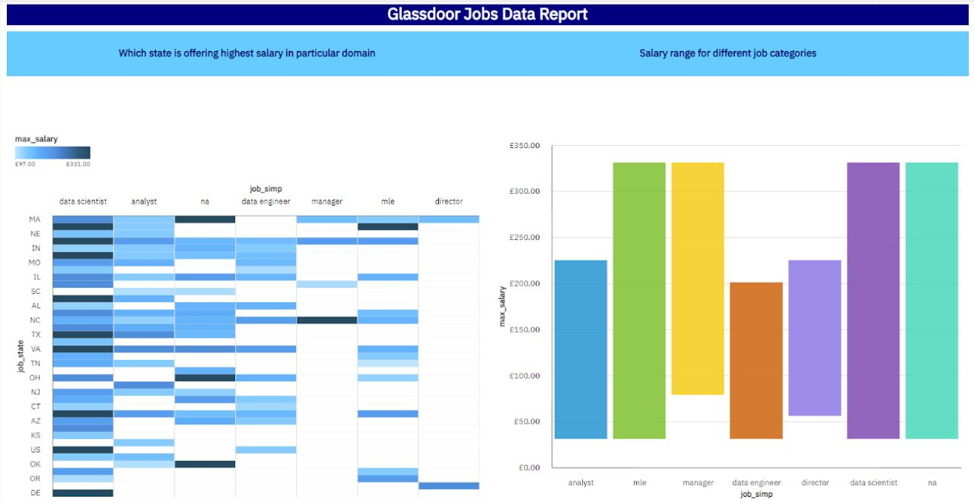

### 

### **No Of Unique Visualisations**

The number of unique visualisations that can be created with a given dataset. Some common types of visualisations that can be used to analyse the Literacy include bar charts, line charts, heat maps, scatter plots, pie charts, Maps etc. These visualisations can be used to compare performance, track changes over time, show distribution, and relationships between variables, breakdown of revenue and customer demographics, workload, resource allocation and location of different job roles.

**REFERENCE**

Visitation to demo set up a comma so student paste on the printer level of education three subjects and we will write we will write a conditions then reading scope then writing scope we free how to create a dream app first education and go to measure land about emo encounter screen we can see a tree I put average of three now we can a behaviour and then average change the colour of this girl colours from this I am selecting oil good night di Megan apply change the name of the city and put the name I put the performance in relation 11 education select all we can send changes now to change the change we will go to format we will go to setting now we can Pintu now we can see the head performance then inter level education we can see the name of the sheet is also change not this seat the average of the average of the student by the level and we can see that the students master degree this is called visualisation

**REFERENCE 2**

Visualisation where we will see the performances students based on to show you and then you will go to create calculated field please set the formula for it score now let's make for making analysis the making the diagram average now Sumit ki Utkal colour off different colours are good in a fighting and you can change your from your also let's change the background can we change into something breed title also fight change to White change the name of the seed one performance students based on a now we will see the value lunch with students have taken their standard one have got up more average of three subjects ok which is 70.837 where is for the free if the reduced one record 62.199 students work getting a standard lunch or getting more marks of more marks subjects

**REFERENCE 3**

Integrate and stories to web so why we need to integrate that one and story to them so that publishing help us to drag and monitor key performance Matrix to communicate results and progress it also helps a published to stay form make better decisions and communication like like this but before it going to this it will show a pop up in which we have to we have to put our credentials after that it will show this pop up in which we have to give the title that will be shown for this dashboard I have already saved in that public so I am not going to save it again but you have to put the title and then click to the save button now I will show you this is my travel direct YouTube to your account like this this is how we will publish a dashboard publisher dashboard on integrated dashboard to aware also be given from here and we will share we can also share our dashboard like clicking on this and copy the link or the imped code now I will show how to how to integrate a story to with our public so we will again story I will show my story to you so this is the story that you have seen in the I Tablet W public account it is also editable on we can see the whole story from we can see the whole story from here like this this is the second third fourth and 5th visualisation those this is our story begin also story from here to Delhi..

### **Dashboard**

A dashboard is a graphical user interface (GUI) that displays information and data in an organised, easy-to-read format. Dashboards are often used to provide real-time monitoring and analysis of data, and are typically designed for a specific purpose or use case. Dashboards can be used in a variety of settings, such as business, finance, manufacturing, healthcare, and many other industries. They can be used to track key performance indicators (KPIs), monitor performance metrics, and display data in the form of charts, graphs, and tables.

import pandas as pd

import matplotlib.pyplot as plt

# Step 1: Load the data from CSV into a Pandas DataFrame

data_file = "glassdoor_jobs.csv"

df = pd.read_csv(data_file)

# Step 2: Data Summary

# Print the basic information about the dataset

print("Data Summary:")

print(df.info())

# Step 3: Exploratory Data Analysis (EDA)

# Example: Let's analyse the job locations and their counts

location_counts = df['Location'].value_counts().head(10)

# Step 4: Visualisation

plt.figure(figsize=(10, 6))

plt.bar(location_counts.index, location_counts.values)

plt.xticks(rotation=45)

plt.xlabel("Location")

plt.ylabel("Number of Jobs")

plt.title("Top 10 Job Locations")

plt.tight_layout()

plt.show()

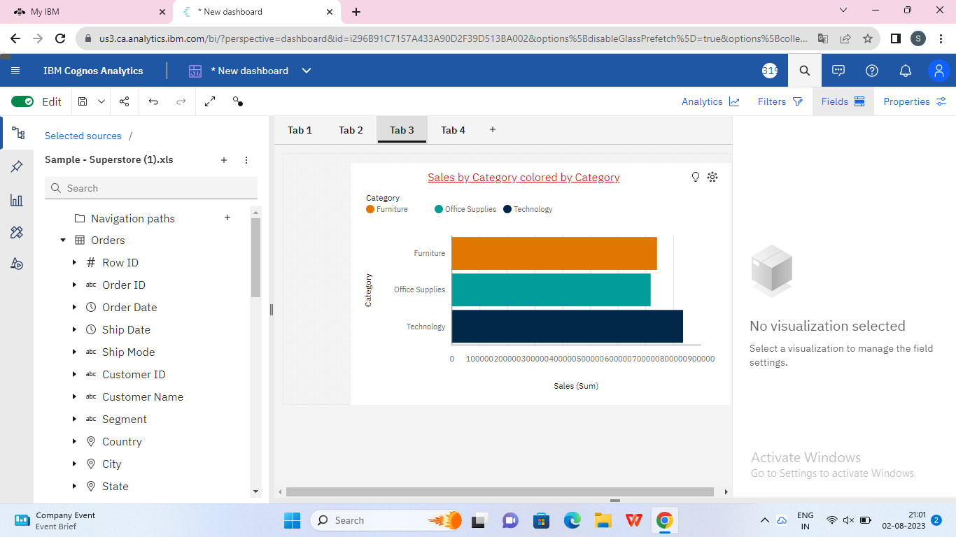

A dashboard is a way of displaying various types of visual data in one place. Usually, a dashboard is intended to convey different, but related information in an easy-to-digest form. And oftentimes, this includes things like key performance indicators (KPI)s or other important business metrics that stakeholders need to see and understand at a glance.

Dashboards are useful across different industries and verticals because they’re highly customizable. They can include data of all sorts with varying date ranges to help you understand: what happened, why it happened, what may happen, and what action you should take. And since dashboards use visualisations like [tables](https://www.tableau.com/data-insights/reference-library/visual-analytics/tables), graphs, and [charts](https://www.tableau.com/data-insights/reference-library/visual-analytics/charts), others who aren’t as close to the data can quickly and easily understand the story it tells or the insights it reveals.

Broadly speaking, **reports** usually have a more narrow focus. They serve the purpose of providing a deep-dive view into a data set and tend to concentrate on a single item or event.

On the other hand, **dashboards** tend to have a high-level view of broad amounts of data and are created to answer a single question. That question can be broad, such as, “how was our site performance last month?” Or more specific, such as, “how many units did we sell?” Or perhaps something that’s a little harder to track without specialised expertise, such as, “is our overall efficiency improving?”

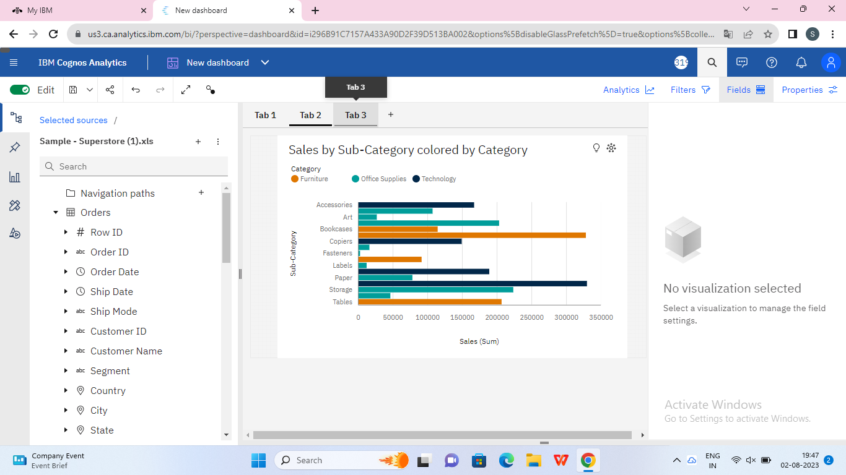

The main use of a dashboard is to show a comprehensive overview of data from different sources. Dashboards are useful for monitoring, measuring, and analyzing relevant data in key areas. They take raw data from many sources and clearly present it in a way that’s highly tailored to the viewer’s needs—whether you’re a business leader, line of business analyst, sales representative, marketer, and more.

Use dashboards to measure things like:

* Customer metrics
* Financial information
* Sales information
* Web analytics
* Manufacturing information
* Human resources data
* Marketing performance
* Logistics information

Since dashboards are useful aggregation and visualisation tools, they’re highly versatile—used by professionals to analyse complex data or subject matter experts to track or present data to non-subject matter experts. Use them in your presentations to executives or other key stakeholders to help them understand challenges, opportunities, where to grow and make changes.

### **Responsive And Design Of Dashboard**

The responsiveness and design of a dashboard for Data-Driven insights on Student Performance is crucial to ensure that the information is easily understandable and actionable. Key considerations for designing a responsive and effective dashboard include user-centered design, clear and concise information, interactivity, data-driven approach, accessibility, customization, and security. The goal is to create a dashboard that is user-friendly, interactive, and data-driven, providing actionable insights.

[Explanation video link](https://drive.google.com/file/d/1qhu7OcB9o8ppDFJPkBkPB9Rg5BlADHre/view?usp=share_link)

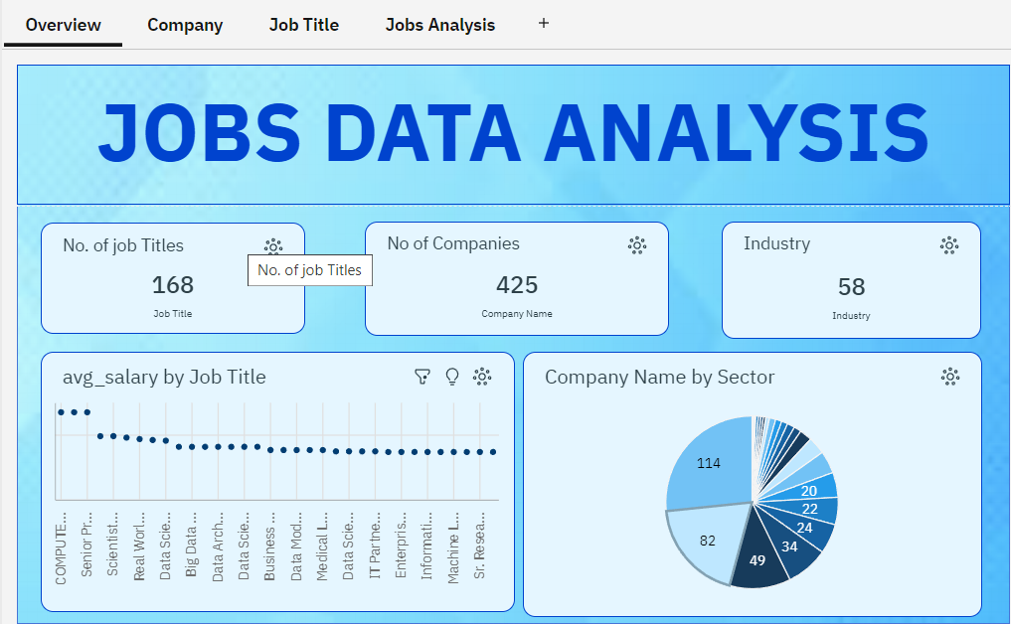

Designing a responsive dashboard involves creating a user interface that adapts to different screen sizes and devices, providing an optimal user experience across desktops, tablets, and smartphones. Here are some key principles and considerations for designing a responsive dashboard:

1. Mobile-First Approach:

Start by designing for mobile devices first, as they have the smallest screen sizes. This approach ensures that the most critical information is presented clearly on smaller screens and can then be expanded for larger displays.

2. Content Hierarchy:

Prioritise content based on its importance. Place the most crucial information and features at the top and make sure they're easily accessible. Less important elements can be hidden or revealed through interactions.

3. Grid Layout:

Use a flexible grid layout that rearranges and resizes elements based on screen size. This allows content to be organised neatly without excessive scrolling.

4. Breakpoints:

Determine key breakpoints at which your layout will adapt. Common breakpoints are for devices like smartphones, tablets, laptops, and large desktop screens. Adjust the layout and content presentation at each breakpoint.

5. Consistent Navigation:

Maintain consistent navigation elements, such as menus and buttons, across different screen sizes. This helps users easily find their way around the dashboard.

6. Condensed Views:

On smaller screens, consider condensing or collapsing less critical information. This can include hiding secondary navigation or displaying summarised data.

7. Touch-Friendly Interactions:

Design touch-friendly interactions for mobile devices. Use larger buttons, swipe gestures, and avoid interactions that require precision.

8. Font Sizes and Readability:

Ensure text is readable on all screen sizes. Use appropriate font sizes, line spacing, and contrast ratios to enhance legibility.

9. Responsive Charts and Graphs:

If your dashboard includes charts and graphs, ensure they're responsive and can be easily understood even on smaller screens. Use simple and clear visualisation techniques.

10. Images and Media:

Optimise images and media for various devices to maintain fast load times. Use CSS techniques like media queries to serve appropriately sized images.

11. Testing:

Regularly test your responsive dashboard on various devices and screen sizes to identify any layout or usability issues. Real-world testing helps ensure a seamless experience.

12. User Feedback:

Gather feedback from users about their experience using the responsive dashboard. This input can provide insights into areas that might need improvement.

Remember, responsive design is about creating a fluid and adaptable user experience. It's a balance between providing essential information and functionality while maintaining a clean and user-friendly interface across different devices.

**REFERENCE OF DASHBOARD**

Dashboard is complete now going to create a report so now let us go to this hamburger menu the main menu and from here we need to click on new and from here we need to click on before when we click on report bill and on the new page where it will ask us to selected template so I am selecting this to buy two template you can select any time period of your choice I am selecting this 2 by 2 template concrete this is the template that I have got now I have to select the source and selecting my data module that I have created for my project so to give the title you just need to double click on it and give the title as whatever title you want you can give I am giving now we need to do the editing in order to do the editing just click on this background colour go to properties go to background colour go to these three dots and select the colours I am selected dark blue colour we can select this navy blue colour I am selecting this navy blue colour and apply and okay now when we have given the dark colour to the background we need to change our brown colour also that means whatever they whatever is there that should be there in the front lighter color to match the you can change it and click on fly and this is how we can do formatting in our report now let us create a first visualisation the first visualisation we will be going to create would be a heat map would be I hate my select heat map from here and click on okay click on Ok after selecting the heat map we need to give the data to the heat map we need to give the data to the heat map with the help of queries so this is the visualisation that we have created render I'll do I just save my report in the same folder in the same folder I am going to save it to properties Colours for this background colour I am going to give a 10th of blue okay now again give the title I am going to give the title here that title I am going to give us title you want to give a you can give but make sure in the report your titles will be some what descriptive rights range different job categories and the same editin I am going to select navy I have to do and for this blue colour background colours okay I'll be changing to when you see this bar then there if it is vertical bar you will get it in Call of if it is horizontal you will get it in rose so we need to drop in column to make sure that it is a vertical bar when you are drop AWS also I'll do the same WhatsApp apply and okay so this is the third visualisation for our what we will be having a combination visualisation for that we will be using line.

### **Story**

A data story is a way of presenting data and analysis in a narrative format, with the goal of making the information more engaging and easier to understand. A data story typically includes a clear introduction that sets the stage and explains the context for the data, a body that presents the data and analysis in a logical and systematic way, and a conclusion that summarises the key findings and highlights their implications. Data stories can be told using a variety of mediums, such as reports, presentations, interactive visualisations, and videos.

### **No Of Scenes Of Story**

The number of scenes in a storyboard for Data-Driven insights on Students Performance will depend on the complexity of the analysis and the specific insights that are trying to be conveyed. A storyboard is a visual representation of the data analysis process and it breaks down the analysis into a series of steps or scenes.

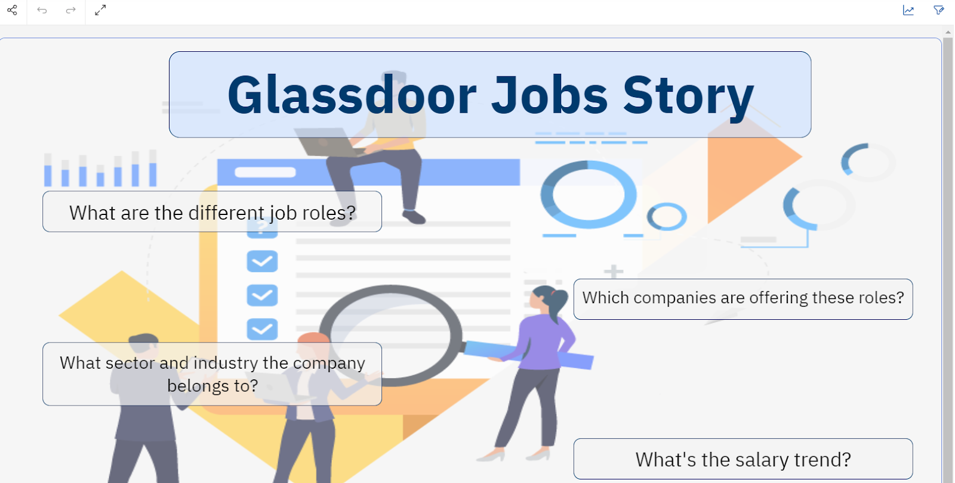

SCENE1

Now, we will proceed forward with creating the story. So here we need to create the story we need to click on and select the story. For the story we need to select a template so we are going with a slideshow only click on create you will be landing on to this new story page.

Now we first need to add the data source so that we can get our explorations here also. So for that on our left hand side we have this option: sources go to this option then click on select a source and then select a data source from your data module that you have created.

So I have created my data module in my content in the last jobs folder and this is my data module using this data module I will be creating my story. Right now in the story we need to make it attractive using the animations, images and all. So first what I will do here is first I will add a background image I will go to the widgets and from here I will select a background image and here to this image what I will do I will

just give a link to an image so this is the image link that I am going to give you can give any image that you like I am going to give this image link here enter

So this is the complete page. We have expanded our image to the complete page right now the background is set. We have set the background for our story. The next thing we have to do is we need to give our title to our story.

So here I will be adding a text box here at the top and here I will be adding the title as a Glass Dupe job story. Now you can expand it as you want you can change like I want it to be centre aligned I want this to be big the colour if you want to change you can change the colour also ok I am giving this colour if you want to change the background so you can change the background of this text box also so I am going to the appearance fill colour.

I am going to fill the colour white if you want to give the border colour you can give the border colours I am going to give the border colour as blue text a little dark blue yeah fine and if you want to change the opacity also you can change the opacity also so background I can adjust like this so this is you can see I have adjusted the background opacity at I will adjust at 50 and I am giving the rounded corners rounded corner radius I am giving 10 so this is how it looks like right

Now we need to add some more text here so what I am going to do I will add one more text box in this text box I am going to write the questions that this story will be answering

I have added the text what are the different job roles you can adjust it as per your requirement I am adjusting it as per my requirement I am giving the text colour as white I am doing it centre align

Now I will go to the settings and in the appearance I give the background colour as you can give any colour as you want I am just trying if it is looking good we will set this only

so here I am going to change the text colour to black itself and in the general appearance I am going the border colour as dark blue we will get the corner radius as 10 widget opacity we can increase some opacity till 70 and yeah this is done.

okay now what I'll do I will just create a copy of this select this create copy of it again duplicate again duplicate it depends on how many questions you want so I am going to add multiple questions so I have duplicated it multiple times if you don't want to add multiple questions you can add it how many times you want I want different different questions to be added here okay so now I will be adding the questions

So factor and industry the company belongs and then what is the salary tren

fine so this is how you can add multiple questions as per your requirement as per your story whatever you want to

so so you can have multiple questions and you can adjust these as you want

Okay so this is how I have adjusted the questions now what I'll do I'll just give the animation to each part of it so start it and I'll give 15 seconds

So for the background image it should start at zero second and it should remain at the till the end 15 seconds then for two seconds and exit at 15 only then this four exit at 15

Okay then for this question it should enter at 15 exit at 15 and start at 5.5 then for this question this question exit and start at seven whatever animation you would like to give you can give I'm just giving randomly I'm just giving a space of 1.5 second in each question

Okay yeah so this is how I have added the animation now I will show you first I'm going to save this story okay I'm going to save it in the folder glass door jobs so this is the scene one of my story now I will play it and I will show you okay so I will play this just see this

at two second this entered or this entered then this then this question and then this question entered okay if you want to add anything else you can add anything else but I don't want to add anything else fine this was the first scene of the story this was the first scene of the story

**SCENE 2&3**

For the story we need to select templates of we are going with a slideshow only new story page left hand side we have this option sources right now in story we need to make it attractive using the animation images and all right so first I what I will do here is first I will add a background image I am from here I will select a background image image but I will do I will just get a link to an image imaging that I am going to give you can give any email that you like we need to spend our image to the complete background for our story I will be adding a text top here I will be adding the title as plazo story now you can expanded as you want you can change like I want it to be Centre align I want background of the text box also Sang going to the appearance fill colour I am going to fill the colour white if you want to get the product colours I am going to give the product if you want to change the opacity also you can change and I am giving the rounded corners rounded corner radius I am giving fan so this is our looks like now we need to add some more text here so what I am going to do I will add one more text box in this text box I am going to write the questions story will be answering I have added the text what are the different job roles you can adjusted as by your requirement I am adjusting it as per my requirement now I will go to the settings and background colour as any colour as you want I'm just trying if it is looking good we will set this only you can have multiple question and of my story now I will play it and I show you anything else and then discussion enter

### **Report**

A report in data analytics typically involves analysing and interpreting data to draw insights and conclusions that can inform business decisions or address research questions. The report usually includes a summary of the data analysis process, including the methods and tools used, as well as the findings and recommendations based on the analysis. The report should begin with an executive summary, which provides a brief overview of the main findings and recommendations. The introduction should provide background information on the problem or research question being addressed and the data sources used.

**REFERENCE**

Dashboard is complete now going to create a report so now let us go to this hamburger menu the main menu and from here we need to click on new and from here we need to click on before when we click on report bill and on the new page where it will ask us to selected template so I am selecting this to buy two template you can select any time period of your choice I am selecting this 2 by 2 template concrete this is the template that I have got now I have to select the source and selecting my data module that I have created for my project so to give the title you just need to double click on it and give the title as whatever title you want you can give I am giving now we need to do the editing in order to do the editing just click on this background colour go to properties go to background colour go to these three dots and select the colours I am selected dark blue colour we can select this navy blue colour I am selecting this navy blue colour and apply and okay now when we have given the dark colour to the background we need to change our brown colour also that means whatever they whatever is there that should be there in the front lighter color to match the you can change it and click on fly and this is how we can do formatting in our report now let us create a first visualisation the first visualisation we will be going to create would be a heat map would be I hate my select heat map from here and click on okay click on Ok after selecting the heat map we need to give the data to the heat map we need to give the data to the heat map with the help of queries so this is the visualisation that we have created render I'll do I just save my report in the same folder in the same folder I am going to save it to properties Colours for this background colour I am going to give a 10th of blue okay now again give the title I am going to give the title here that title I am going to give us title you want to give a you can give but make sure in the report your titles will be some what descriptive rights range different job categories and the same editin I am going to select navy I have to do and for this blue colour background colours okay I'll be changing to when you see this bar then there if it is vertical bar you will get it in Call of if it is horizontal you will get it in rose so we need to drop in column to make sure that it is a vertical bar when you are drop AWS also I'll do the same WhatsApp apply and okay so this is the third visualisation for our what we will be having a combination visualisation for that we will be using line I am going to take company age dashboard is done a reported

### **No Of Visualization With Detailed Information**

When creating a report in Cognos, it is often helpful to include visualisations to help communicate the findings of the analysis.

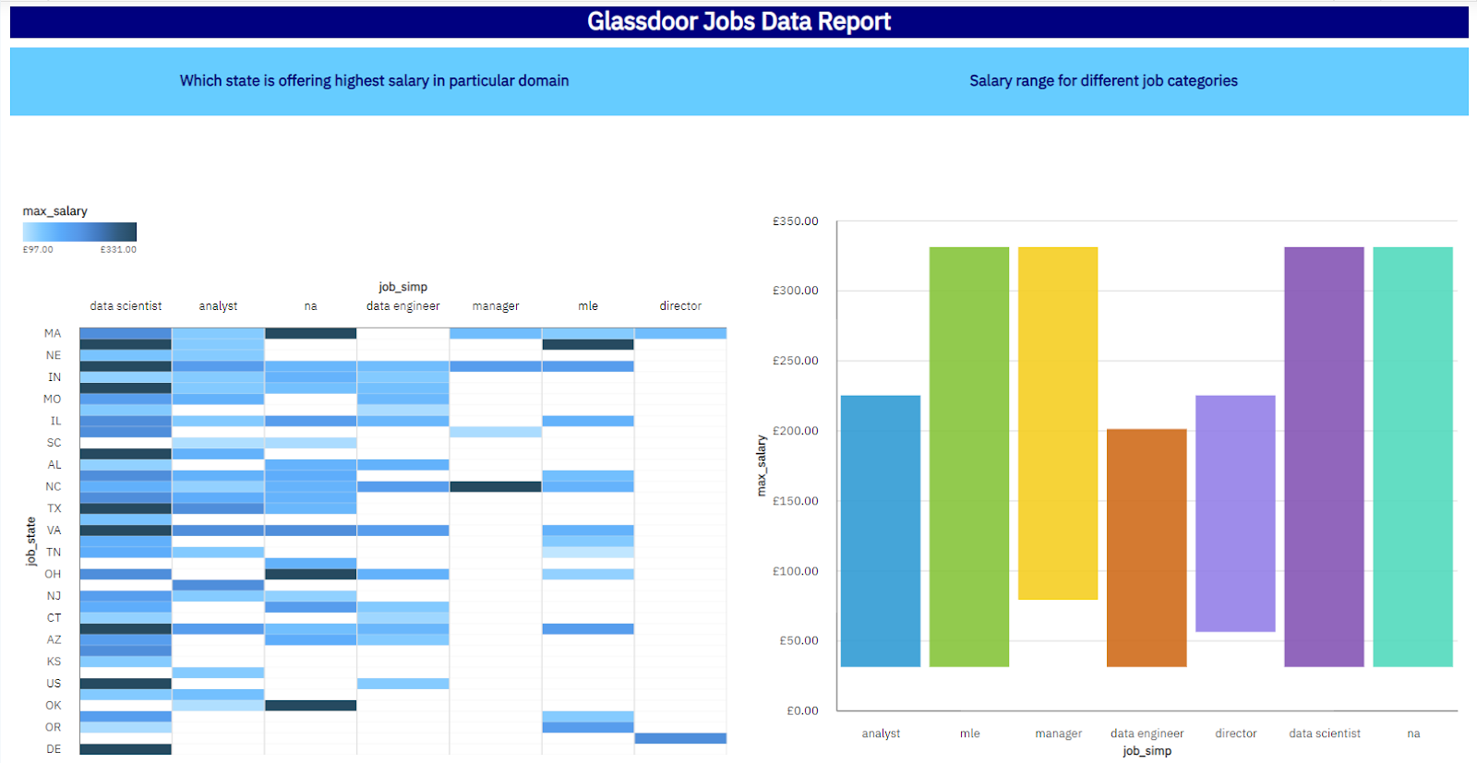

### **Performance Testing**

The causes of problems with DB2 Performance can result from many forms of change, including the following:

* Physical changes to the environment, such as a new CPU or different tape drives.
* Installing a new version or release of the operating system.
* Changes to system software, such as a new release of a product, the alteration of a product, or a new product. Also included is the installation of a new release or version of DB2, which can result in changes in access paths and the utilisation of features new to DB2.
* Changes to the DB2 engine from maintenance releases, which can change the optimizer.
* Changes in system capacity. More or fewer jobs could be executing concurrently when the performance problem occurs.
* Environment changes, such as the implementation of client/server programs or the adoption of data sharing.
* Database changes. This involves changes to any DB2 object, ranging from adding a new column or an index to dropping and re-creating an object.
* Changes to the application development methodology, such as usage of check constraints instead of application logic or the use of stored procedures.
* Changes to application code.
* 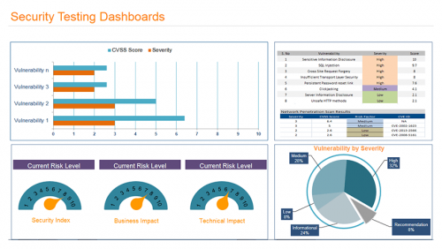

### **Amount Of Data Rendered To DB2**

The amount of data that is rendered to a database depends on the size of the dataset and the capacity of the database to store and retrieve data.

Dashboards are data visualisation tools that monitor, analyse, and display key performance indicators (KPIs), metrics, and key data points. Dashboards enable technical and non-technical users to understand and apply business intelligence to make better decisions. Users actively participate in the analysis process by compiling data and visualising trends and occurrences and viewers. It is also used to convey messages and understand patterns easily and often. It also helps you better understand the relationships between your data. Displaying data is important because viewing data in a one-million-row Excel spreadsheet, it’s hard to read or even understand. Whereas, when viewed via a graphical representation, it will help you make faster decisions and reach your goals. The ability to see an overview of all data points for a quick understanding of distributions and relationships. These can provide additional context to help confirm the conclusions you want to draw

### **Utilisation Of Data Filters**

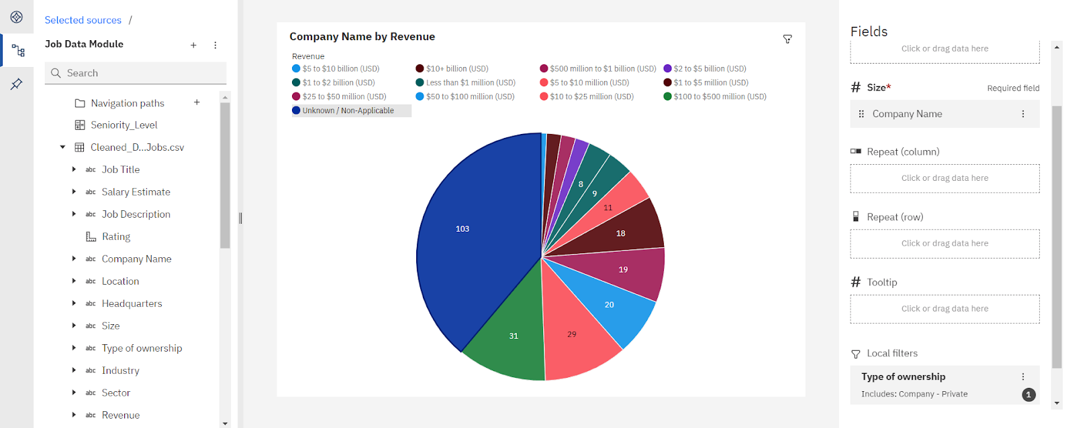

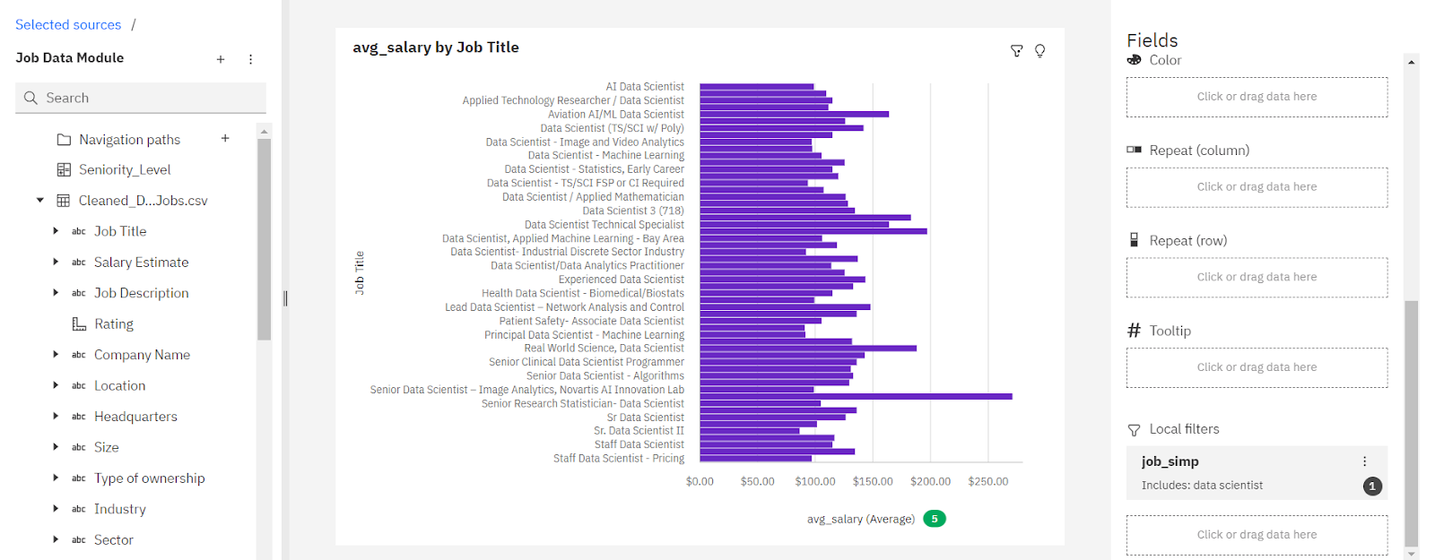

### **No Of Calculation Fields**

A calculated field (also known as a calculated column, expression field, or expression column) is a custom column whose value is a computed value of an expression. This field comprises built-in functions as well as formulas and other columns in the underlying data table. With calculated fields, you can make simple arithmetic operations or complex mathematical and logical operations, type conversions, and more. In [Bold BI](https://www.boldbi.com/) dashboards, you can create a calculated field with measure or dimension fields from the underlying data source and built-in functions. Then, easily configure that field to certain widgets. Calculated fields play a key role in any business analytics process. This blog post will answer the following questions on calculated fields and visualise them effectively using Bold BI:



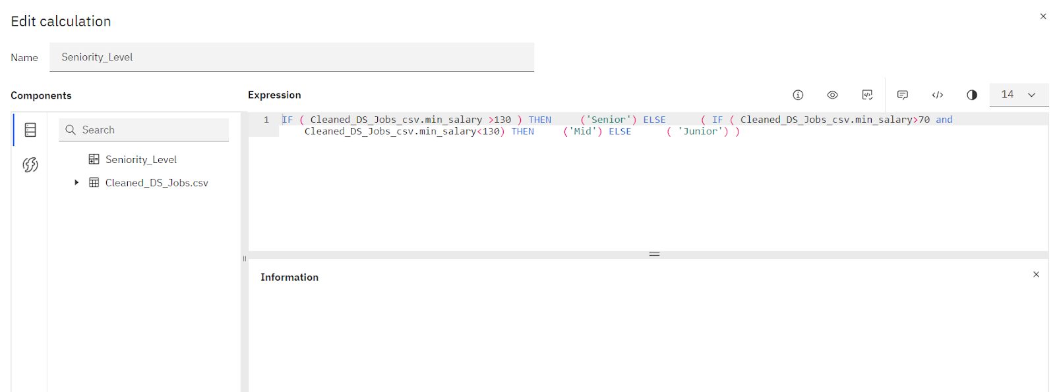

### **No Of Visualisations/ Graphs**

1. What is the salary trend for a particular job title?

2. No of companies belonging to different Sector

3. How many companies belong to the particular location?

4. What's the distribution of companies according to the type of owner?

5. Most popular sector on glassdoor for data science domain

6. Top 10 rated jobs

7. Which Industry is offering more job roles

8. Which state is providing more opportunities

9. Show job titles from different category

10. Compare salary trend of different industry

11. Top 10 highest paying jobs from different states

12. what is the avg_salary of Job Title belonging from particular Location

13. What is the revenue generated by companies that falls under particular category of ownership

14. Salary trend for different job titles belonging to particular job category

15. What is the rating & salary offered in particular job state

16. Salary trend in different states for particular seniority level

### **Web Integration**

Publishing helps us to track and monitor key performance metrics, to communicate results and progress. help a publisher stay informed, make better decisions, and communicate their performance to others.

Publishing dashboard, report & story.

Step 1: Go to Dashboard, report & /story, click on share button on the top.

**Dashboard**

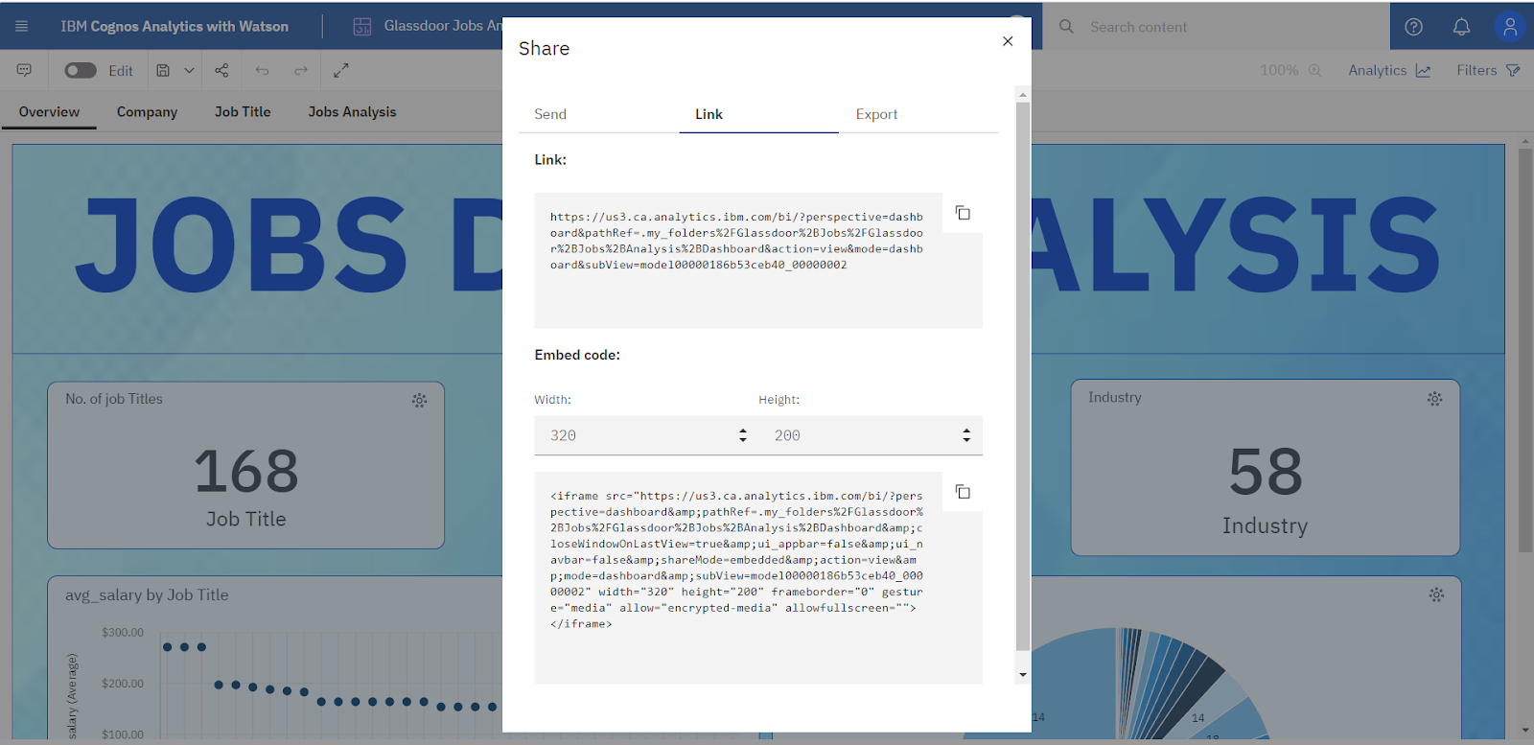

**Story**

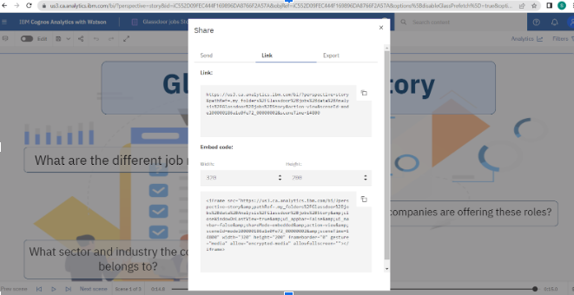

**Report**

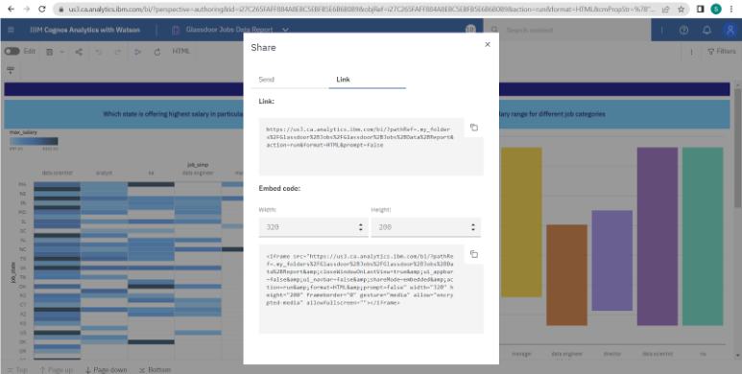

**REFERENCE**

After every visualisation is done a dashboard record story is done after that we need to create a web application for our project need to do you need to go to any browser and search for free bootstrap template and select any one templet that you like and that you think is as per your requirement right I have downloaded one temperate and now in the template what you need to do all the things like CSS images all these things you need to keep in static folder and so this is this structure all the files all the extra script pirate images should be in static holder and the HTML file should be in templates and file to find these together should be app.py that should be inside the main folder outside the straight now what you need to do is you need to open Spider you need to open Spider and go here to the folder and browse your project folder and Browser you need to open app.p y this is how your page will be the main thing is everyone route whenever I open my website it should be routed it should render the template index.html and this is the main function where Deepak is equals to true if the bag is equals to prove we will launch it via and a conductors I am going to open Anaconda from on to the Anaconda from Alpha School inside this folder inside the folder just go to your project folder and here this is the link to my this is the part to my folder as this is the Python file app we need to run it Fallen link I want place at here right you need to do with similarly you need to do with report and story also so let us do for report also report I will just open my report sharing link link report hide I will exhaust to we can edit it later also if you want to access it we can edit it later also into spider and my I want to I have drop it now for the story also I will do the same thing for the story also I'll do the same thing hair on Anaconda from I have run the command like this I have copied the path CD given the path here then Python app dot TY then I got this link instead of this link as just type local and 5000 and this is being render so have what I will do I just copy the story link also share to make sure that it should be in the same window where you are locked in adjust the weight of the trenders done nothing I have just now here you can see it is loading my reporters loading and my story is also loading I have done nothing I have just from here I have changed the I have just change the height with I have not touch for any of these issue because I was placing outside them inside them

### 

### 

### 

### 

### **Dashboard, Report And Story Embed With UI With Flask**



